ECA5801-IOE AND AI DRIVEN SYSTEM
EXPERIMENT 5:
- Simulation and Performance Evaluation of RFID/NFC-Based Device Identification and IoE Data Integration using Node-RED, MQTT.

PROGRAM CODE:
# ================================================================
# EXPERIMENT (a)
# Simulation and Performance Evaluation of RFID/NFC-Based
# Device Identification and IoE Data Integration
# using Node-RED and MQTT
# ================================================================

import pandas as pd
import numpy as np
import matplotlib.pyplot as plt
from datetime import datetime

np.random.seed(42)

# ================================================================
# 1. RFID/NFC DEVICE DATABASE
# ================================================================

devices = {
"RFID001": {
"Device": "Temperature Sensor",
"Location": "Laboratory",
"Technology": "RFID"
},

"RFID002": {
"Device": "Humidity Sensor",
"Location": "Laboratory",
"Technology": "RFID"
},

"NFC001": {
"Device": "Smart Door Lock",
"Location": "Main Entrance",
"Technology": "NFC"
},

"NFC002": {
"Device": "Control Unit",
"Location": "Control Room",
"Technology": "NFC"
}
}

# ================================================================
# 2. RFID/NFC TAG SCANNING
# ================================================================

print("=" * 70)
print("RFID/NFC DEVICE IDENTIFICATION")
print("=" * 70)

# Simulated RFID/NFC scans
scanned_tags = [
"RFID001",
"RFID002",
"NFC001",
"NFC002",
"RFID001",
"NFC001",
"UNKNOWN001"
]

results = []

for tag in scanned_tags:

timestamp = datetime.now().strftime("%H:%M:%S")

if tag in devices:

device = devices[tag]

results.append([
timestamp,
tag,
device["Device"],
device["Location"],
device["Technology"],
"SUCCESS"
])

print(
f"Tag: {tag} | "
f"Device: {device['Device']} | "
f"Status: SUCCESS"
)

else:

results.append([
timestamp,
tag,
"Unknown",
"Unknown",
"Unknown",
"FAILED"
])

print(
f"Tag: {tag} | "
f"Device: Unknown | "
f"Status: FAILED"
)

# ================================================================
# 3. IDENTIFICATION TABLE
# ================================================================

identification_df = pd.DataFrame(
results,
columns=[
"Time",
"Tag ID",
"Device",
"Location",
"Technology",
"Status"
]
)

print("\nIDENTIFICATION RESULTS")
display(identification_df)

# ================================================================
# 4. GENERATE IoE DATA
# ================================================================

print("\n" + "=" * 70)
print("IoE DATA GENERATION")
print("=" * 70)

ioe_data = []

for tag in scanned_tags:

if tag not in devices:
continue

device = devices[tag]

if device["Device"] == "Temperature Sensor":

value = round(
np.random.uniform(24, 35),
2
)

unit = "°C"

elif device["Device"] == "Humidity Sensor":

value = round(
np.random.uniform(40, 80),
2
)

unit = "%"

elif device["Device"] == "Smart Door Lock":

value = np.random.choice(
["OPEN", "CLOSED"]
)

unit = "State"

else:

value = np.random.randint(
1,
100
)

unit = "units"

ioe_data.append([
tag,
device["Device"],
device["Location"],
value,
unit
])

ioe_df = pd.DataFrame(
ioe_data,
columns=[
"Tag ID",
"Device",
"Location",
"Value",
"Unit"
]
)

display(ioe_df)

# ================================================================
# 5. MQTT MESSAGE GENERATION
# ================================================================

print("\n" + "=" * 70)
print("MQTT MESSAGE GENERATION")
print("=" * 70)

mqtt_messages = []

for _, row in ioe_df.iterrows():

topic = (
"IoE/"
+ row["Location"].replace(" ", "_")
+ "/"
+ row["Device"].replace(" ", "_")
)

payload = (
"{"
f"'device_id':'{row['Tag ID']}', "
f"'device':'{row['Device']}', "
f"'value':'{row['Value']}', "
f"'unit':'{row['Unit']}'"
"}"
)

mqtt_messages.append([
topic,
payload
])

print("MQTT PUBLISH")
print("Topic :", topic)
print("Payload :", payload)
print("-" * 60)

mqtt_df = pd.DataFrame(
mqtt_messages,
columns=[
"MQTT Topic",
"MQTT Payload"
]
)

# ================================================================
# 6. NODE-RED DATA PROCESSING
# ================================================================

print("\n" + "=" * 70)
print("NODE-RED DATA PROCESSING")
print("=" * 70)

processed_data = []

for _, row in ioe_df.iterrows():

device = row["Device"]
value = row["Value"]

if device == "Temperature Sensor":

if value > 32:
status = "HIGH"
else:
status = "NORMAL"

elif device == "Humidity Sensor":

if value > 70:
status = "HIGH"
else:
status = "NORMAL"

elif device == "Smart Door Lock":

status = value

else:

status = "ACTIVE"

processed_data.append([
row["Tag ID"],
device,
row["Location"],
value,
row["Unit"],
status
])

processed_df = pd.DataFrame(
processed_data,
columns=[
"Tag ID",
"Device",
"Location",
"Value",
"Unit",
"Node-RED Status"
]
)

display(processed_df)

# ================================================================
# 7. IDENTIFICATION SUCCESS RATE
# ================================================================

total_scans = len(scanned_tags)

successful_scans = sum(
identification_df["Status"] == "SUCCESS"
)

failed_scans = total_scans - successful_scans

success_rate = (
successful_scans /
total_scans
) * 100

print("\n" + "=" * 70)
print("PERFORMANCE RESULT")
print("=" * 70)

print("Total Scans :", total_scans)
print("Successful Scans :", successful_scans)
print("Failed Scans :", failed_scans)
print(
"Identification Success Rate:",
round(success_rate, 2),
"%"
)

# ================================================================
# 8. IDENTIFICATION PERFORMANCE GRAPH
# ================================================================

plt.figure(figsize=(8, 5))

plt.bar(
["Successful", "Failed"],
[successful_scans, failed_scans]
)

plt.xlabel("Identification Result")
plt.ylabel("Number of Tags")
plt.title("RFID/NFC Device Identification Performance")

plt.grid(
axis="y",
linestyle="--",
alpha=0.5
)

plt.show()

# ================================================================
# 9. FINAL DATA INTEGRATION RESULT
# ================================================================

print("\n" + "=" * 70)
print("FINAL IoE DATA INTEGRATION")
print("=" * 70)

print("""
RFID/NFC TAG
↓
DEVICE IDENTIFICATION
↓
IoE DATA GENERATION
↓
MQTT TOPIC + PAYLOAD
↓
NODE-RED PROCESSING
↓
PROCESSED IoE DATA
""")

print(
"Total MQTT Messages:",
len(mqtt_messages)
)

print(
"Identification Success Rate:",
round(success_rate, 2),
"%"
)
OUTPUT:
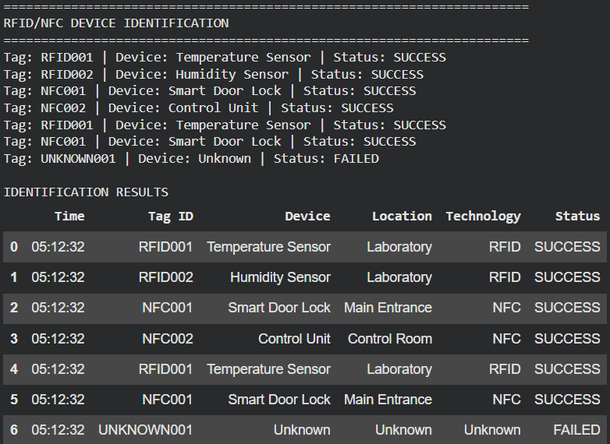

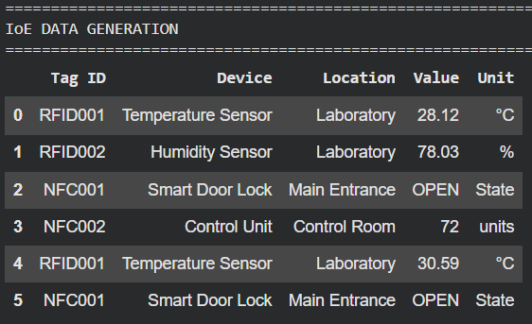

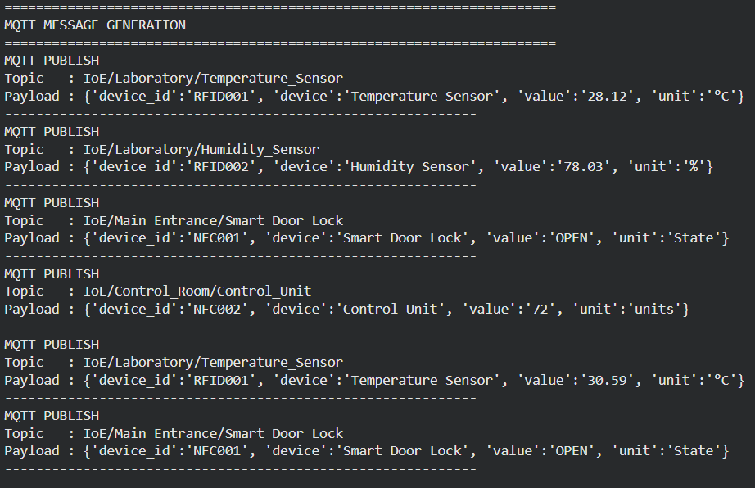

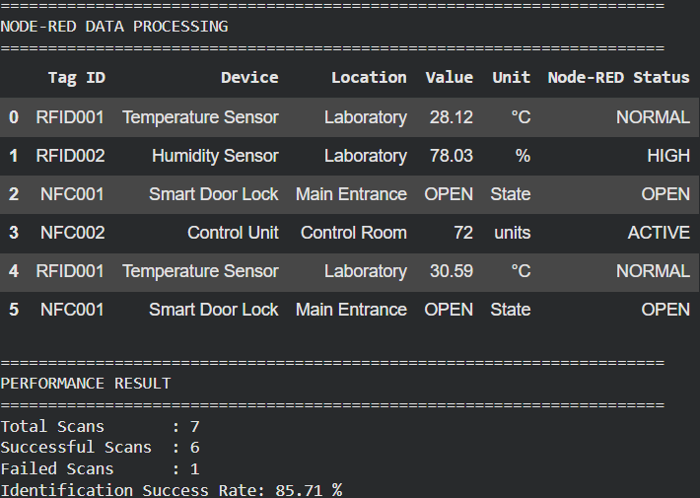

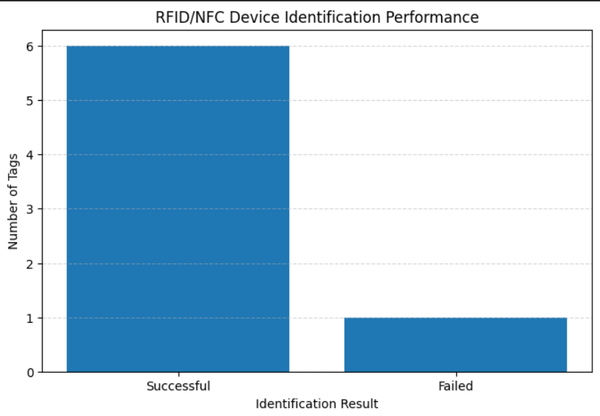

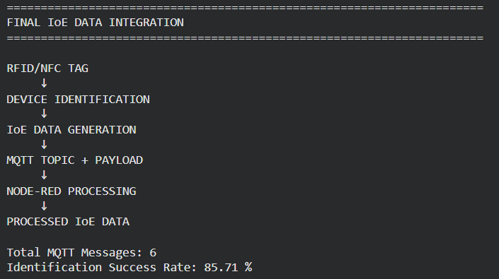

EXPERIMENT 5:
- Modelling and Simulation of a 4-Layer IoE Architecture (Perception–Network–Middleware–Application) using Node-RED, MQTT and a Cloud Dashboard

PROGRAM:
# ================================================================
# Modelling and Simulation of a 4-Layer IoE Architecture
# (Perception - Network - Middleware - Application)
# using Node-RED, MQTT and Cloud Dashboard
# ================================================================

import pandas as pd
import numpy as np
import matplotlib.pyplot as plt

np.random.seed(42)

# ================================================================
# 1. IoE DEVICE CONFIGURATION
# ================================================================

devices = [
"Temperature Sensor",
"Humidity Sensor",
"Light Sensor",
"Motion Sensor"
]

locations = [
"Laboratory",
"Laboratory",
"Classroom",
"Classroom"
]

# ================================================================
# 2. LAYER 1 — PERCEPTION LAYER
# ================================================================

print("=" * 75)
print("LAYER 1 — PERCEPTION LAYER")
print("=" * 75)

perception_data = []

for i in range(len(devices)):

device = devices[i]
location = locations[i]

if device == "Temperature Sensor":

value = round(
np.random.uniform(24, 35),
2
)

unit = "°C"

elif device == "Humidity Sensor":

value = round(
np.random.uniform(40, 80),
2
)

unit = "%"

elif device == "Light Sensor":

value = round(
np.random.uniform(100, 900),
2
)

unit = "lux"

else:

value = np.random.choice(
[0, 1]
)

unit = "Motion"

perception_data.append([
device,
location,
value,
unit
])

perception_df = pd.DataFrame(
perception_data,
columns=[
"Device",
"Location",
"Sensor Value",
"Unit"
]
)

print("Sensors collect physical-world data:")

display(perception_df)

# ================================================================
# 3. LAYER 2 — NETWORK LAYER
# ================================================================

print("\n" + "=" * 75)
print("LAYER 2 — NETWORK LAYER")
print("=" * 75)

mqtt_data = []

for _, row in perception_df.iterrows():

topic = (
"IoE/"
+ row["Location"].replace(" ", "_")
+ "/"
+ row["Device"].replace(" ", "_")
)

payload = (
"{"
f"'device':'{row['Device']}', "
f"'location':'{row['Location']}', "
f"'value':{row['Sensor Value']}, "
f"'unit':'{row['Unit']}'"
"}"
)

mqtt_data.append([
topic,
payload
])

print("MQTT PUBLISH")
print("Topic :", topic)
print("Payload :", payload)
print("-" * 60)

mqtt_df = pd.DataFrame(
mqtt_data,
columns=[
"MQTT Topic",
"MQTT Payload"
]
)

display(mqtt_df)

# ================================================================
# 4. LAYER 3 — MIDDLEWARE LAYER
# ================================================================

print("\n" + "=" * 75)
print("LAYER 3 — MIDDLEWARE LAYER")
print("=" * 75)

middleware_data = []

for _, row in perception_df.iterrows():

device = row["Device"]
value = row["Sensor Value"]

# Node-RED processing rules

if device == "Temperature Sensor":

if value > 32:
status = "ALERT"
else:
status = "NORMAL"

elif device == "Humidity Sensor":

if value > 70:
status = "ALERT"
else:
status = "NORMAL"

elif device == "Light Sensor":

if value < 200:
status = "LOW LIGHT"
else:
status = "NORMAL"

elif device == "Motion Sensor":

if value == 1:
status = "MOTION DETECTED"
else:
status = "NO MOTION"

middleware_data.append([
device,
row["Location"],
value,
row["Unit"],
status
])

middleware_df = pd.DataFrame(
middleware_data,
columns=[
"Device",
"Location",
"Value",
"Unit",
"Node-RED Status"
]
)

display(middleware_df)

# ================================================================
# 5. LAYER 4 — APPLICATION LAYER
# ================================================================

print("\n" + "=" * 75)
print("LAYER 4 — APPLICATION / CLOUD DASHBOARD")
print("=" * 75)

dashboard_df = middleware_df.copy()

display(dashboard_df)

# ================================================================
# 6. DASHBOARD GRAPH
# ================================================================

plt.figure(figsize=(10, 5))

plt.bar(
dashboard_df["Device"],
dashboard_df["Value"]
)

plt.xlabel("IoE Device")
plt.ylabel("Sensor Value")

plt.title(
"IoE Cloud Dashboard - Device Data"
)

plt.xticks(
rotation=20
)

plt.grid(
axis="y",
linestyle="--",
alpha=0.5
)

plt.show()

# ================================================================
# 7. IoE FOUR-LAYER DATA FLOW
# ================================================================

print("\n" + "=" * 75)
print("4-LAYER IoE DATA FLOW")
print("=" * 75)

print("""
┌──────────────────────────────────────┐
│ APPLICATION LAYER │
│ Cloud Dashboard │
└──────────────────┬───────────────────┘
↑
│ Processed Data
│
┌──────────────────┴───────────────────┐
│ MIDDLEWARE LAYER │
│ Node-RED │
│ Data Processing │
└──────────────────┬───────────────────┘
↑
│ MQTT Messages
│
┌──────────────────┴───────────────────┐
│ NETWORK LAYER │
│ MQTT Communication │
└──────────────────┬───────────────────┘
↑
│ Sensor Data
│
┌──────────────────┴───────────────────┐
│ PERCEPTION LAYER │
│ IoE Sensors │
└──────────────────────────────────────┘
""")

# ================================================================
# 8. DATA FLOW PERFORMANCE
# ================================================================

total_devices = len(perception_df)

mqtt_messages = len(mqtt_df)

processed_messages = len(middleware_df)

dashboard_records = len(dashboard_df)

print("=" * 75)
print("DATA FLOW RESULTS")
print("=" * 75)

print(
"Perception Layer Records :", total_devices
)

print(
"MQTT Messages Transmitted:",
mqtt_messages
)

print(
"Node-RED Messages Processed:",
processed_messages
)

print(
"Dashboard Records:",
dashboard_records
)

# ================================================================
# 9. DATA FLOW SUCCESS RATE
# ================================================================

if total_devices > 0:

network_success = (
mqtt_messages /
total_devices
) * 100

middleware_success = (
processed_messages /
mqtt_messages
) * 100

dashboard_success = (
dashboard_records /
processed_messages
) * 100

else:

network_success = 0
middleware_success = 0
dashboard_success = 0

print("\nData Flow Performance")

print(
"Perception → Network:",
round(network_success, 2),
"%"
)

print(
"Network → Middleware:",
round(middleware_success, 2),
"%"
)

print(
"Middleware → Application:",
round(dashboard_success, 2),
"%"
)

# ================================================================
# 10. DATA FLOW PERFORMANCE GRAPH
# ================================================================

layers = [
"Perception",
"Network",
"Middleware",
"Application"
]

records = [
total_devices,
mqtt_messages,
processed_messages,
dashboard_records
]

plt.figure(figsize=(9, 5))

plt.bar(
layers,
records
)

plt.xlabel("IoE Layer")
plt.ylabel("Number of Data Records")

plt.title(
"Data Flow Through 4-Layer IoE Architecture"
)

plt.grid(
axis="y",
linestyle="--",
alpha=0.5
)

plt.show()

# ================================================================
# 11. FINAL RESULT
# ================================================================

print("\n" + "=" * 75)
print("FINAL EXPERIMENT RESULT")
print("=" * 75)

print("""
PERCEPTION
↓
Sensors collect physical data
↓
NETWORK
↓
MQTT transfers IoE messages
↓
MIDDLEWARE
↓
Node-RED processes the messages
↓
APPLICATION
↓
Cloud Dashboard displays the information
""")

print(
"Total IoE Devices:",
total_devices
)

print(
"Total MQTT Messages:",
mqtt_messages
)

print(
"Total Processed Messages:",
processed_messages
)

print(
"Total Dashboard Records:",
dashboard_records
)

OUTPUT :
